**2.Raspberry Pi platform-------Color_LED**

1. **Preparation**

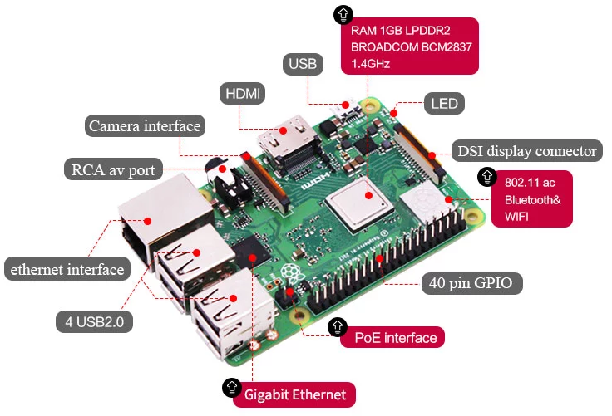

1-1 Raspberry Pi board

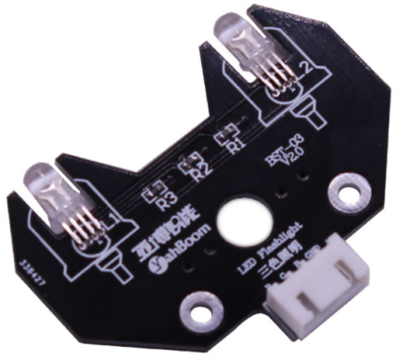

1-2 RGB module

1. **Purpose of Experimental**

After running the Color_LED executable in the Raspberry Pi system and you can see the lights in 7 different colors.

1. **Principle of experimental**

3 LEDs (red, green, blue) are packaged in the RGB lamp module. We can mix different colors(256*256*256) by controlling the brightness of the three LEDs.

According to the circuit schematic, the RGB lamp is a common cathode LED, one pin is connect to GND, and the remaining three pins are respectively connected to the wiringPi port 3, 2, 5 on the Raspberry Pi board. Each LED needs to be connected in series with a 220Ω resistor as the current limiting resistor. We can control the LED by controlling the corresponding pin to be high level of Raspberry Pi board.

1. **Experimental Steps**

4-1 About the schematic

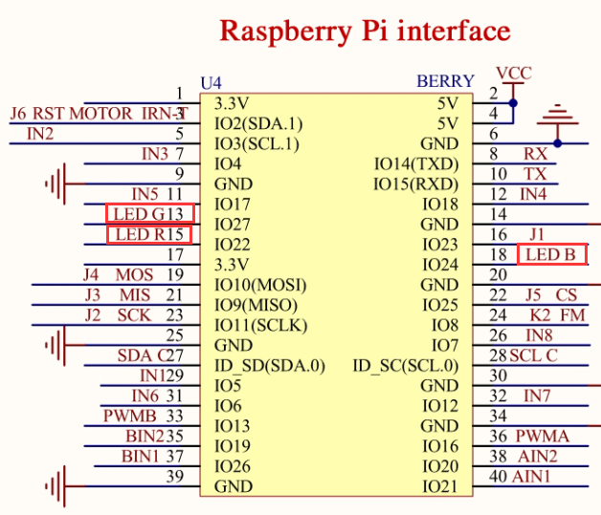

4-1 Raspberry Pi interface circuit diagram

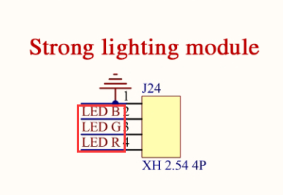

4-2 RGB module interface circuit diagram

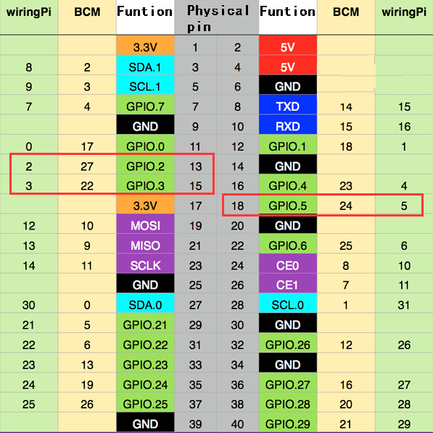

4-3 Raspberry Pi 40 pins comparison table

4-2 According to the circuit schematic:

LED_R-----15(Physical pin)----- 3(wiringPi)

LED_G-----13(Physical pin)----- 2(wiringPi)

LED_B-----18(Physical pin)----- 5(wiringPi)

(Note: We use the wiringPi library to write code.)

4-3 About the code

(1) We need to compile this file in the Raspberry Pi system. (Note: we need to add -lwiringPi to the library file.)

We need to input:gcc ColorLED.c -o ColorLED -lwiringPi

(2)We need to run the compiled executable file in the Raspberry Pi system.We need to input: ./ColorLED

As shown in the figure below.

1. We can input: ctrl+c to stop this process, which mean is send a signal to the linux kernel to terminate the current process, but the state of the relevant pin is uncertain at this time, we also need to run a script to initialize all pins.

(Note:The initpin.sh script file is included in the SmartCar directory.)

You need to input:  chmod 777 initpin.sh

./initpin.sh

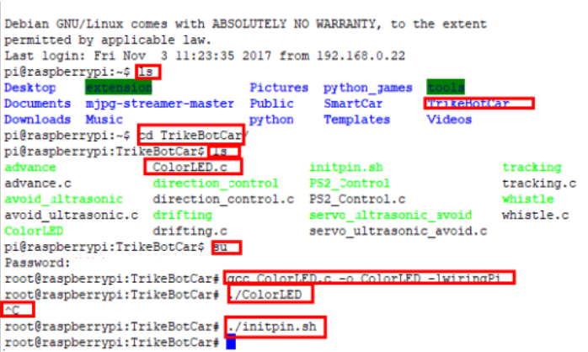

After completing the above steps, the experiment is over.